6.Link Jira tasks with Confluence to streamline task tracking and
progress monitoring for the Library Management System
development.
- Create a new page in Confluence titled "Library Management
System Project Overview."
- Embed at least 5 Jira issues related to the development of the
Library Management System (e.g., tasks from the sprint like
"Develop book search functionality," "Create user login page,"
etc.).
- Use the Jira macro to display issues with status (e.g., "To Do,"
"In Progress," "Done").
- Add a progress bar in the Confluence page to visually track
the completion of each embedded Jira task (e.g., percentage of
tasks completed in the sprint).
- Submit a screenshot of the Confluence page showing the
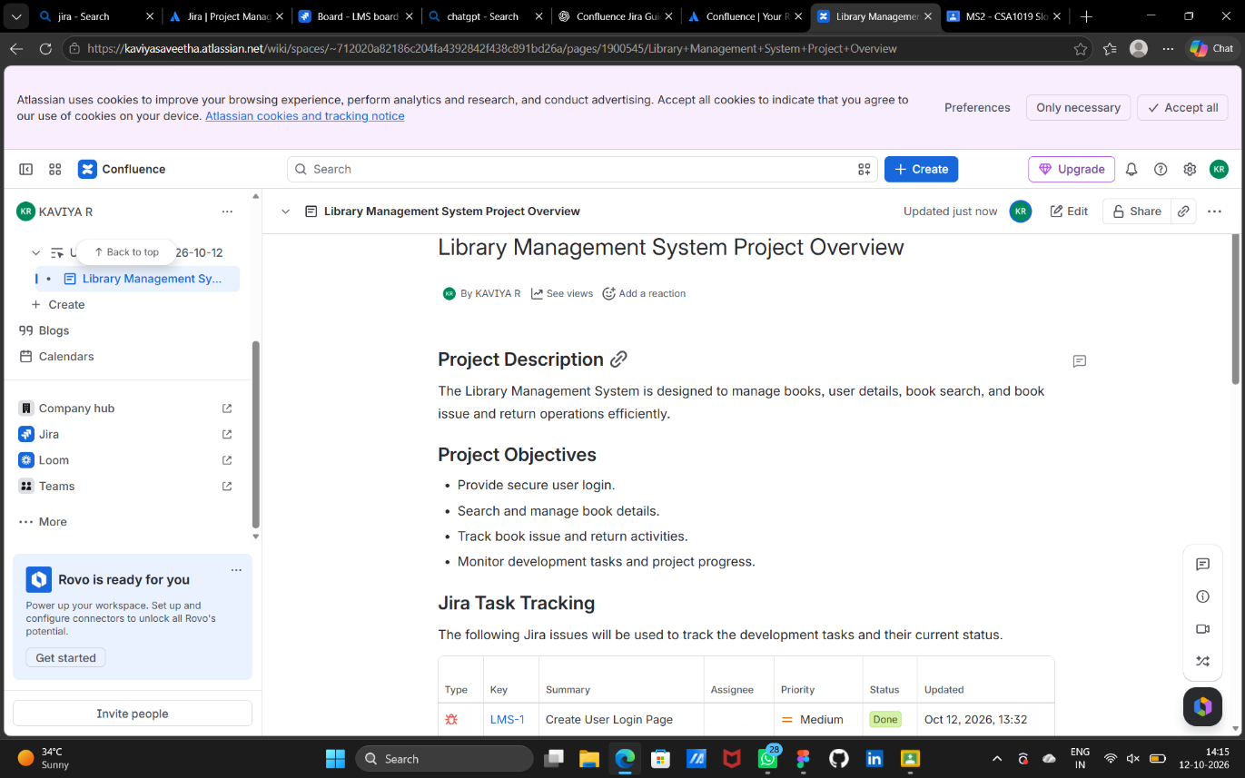
embedded Jira tasks and the progress bar.
